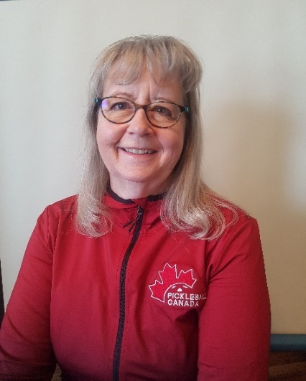 | Karen Rust  I hope everyone had an enjoyable holiday season and is looking forward to a 2022 that is full of the fun, competition, and fellowship that the sport of pickleball brings into our lives.  The Board of Directors and other hard-working volunteers of Pickleball Canada had a busy 2021 with some very exciting strategic initiatives completed, including:  - An agreement with Pickleball Brackets was entered into to provide preferred pricing for clubs using their performance-based ratings and tournament management software and to prepare to implement Canadian Tournament Player Ratings (launching January 2, 2022).  - The recruitment and hiring of Pickleball Canada's first Executive Director, Carla Anderson. Carla's contacts and experience in the Canadian Sport System have had a significant impact on strengthening our organizational capacity.  - The implementation of the Pickleball Canada National System (PCNS) has greatly improved operational effectiveness for PCO, the Provincial/Territorial Sport Organizations (PTSOs) and affiliated clubs. Enhancements are ongoing and we expect to realize even more benefits from the system in future.  - The launch of the National Coaching Certification Program (NCCP) for pickleball through a Collaboration Agreement with Tennis Canada. The NCCP for pickleball is a big step toward obtaining recognition and funding by provincial/territorial and national sport governing bodies and ensures well-trained coaches are ready to support the growing number of Canadians embracing the sport every year.  - The COVID-19 Pandemic eased enough in mid-year that a very successful National Championship and an Atlantic Regional Championship were able to be held.  - Adoption of new policies for Safe Sport and Financial practices. The new Screening policy along with the existing Abuse Prevention policy are necessary elements for clubs that are offering training and programs for youth.  Our active membership count was 28,000 at the end of 2021. We anticipate continued growth throughout 2022 as the popularity of the sport expands and pickleball players learn of the benefits of being part of organized pickleball. We are aware that there are literally thousands of Canadians playing pickleball that do not belong to a local club, provincial sport organization and Pickleball Canada.  You will see the following initiatives delivered in 2022:  - Bylaws Amendments - a project that started in 2018 to bring our Bylaws up to date and align them with governance recommendations for National Sport Organizations is nearing completion. Presentation of the amended bylaws is being readied for a Special Meeting of the membership on April 26, 2022  - Sport Canada Funding - we are positioning Pickleball Canada to be ready to apply for funding when the current freeze on new applications is lifted; tentatively expected to be in 2023.  - Insurance Coverage - has been enhanced by the addition of Abuse Liability coverage for PTSOs and Affiliated clubs that have implemented our Abuse Prevention policy. The Commercial General Liability, Sport Accident and Directors & Officers coverages are also continued. Insurance is the largest expense category for PCO with a total premium cost of $82,000 in 2022.  - The new National Pickleball Advisory Council will meet monthly to enhance communication and collaboration between the PTSOs and Pickleball Canada.  - Canadian Tournament Player Ratings will be maintained and updated for all members competing in PCO sanctioned tournaments.  - Junior/Youth pickleball resources will be assembled and made available.  - Pickleball Canada National and Regional Championships will be held with many additional PCO sanctioned tournaments approved across the country.  The number of projects and initiatives underway are ambitious and cannot be accomplished without the dedication of our many volunteers. If you are interested in getting involved with one of the committees or leadership groups, please reach out to me. There is a great deal of satisfaction to be felt by contributing to the success and growth of this sport we love.
 | 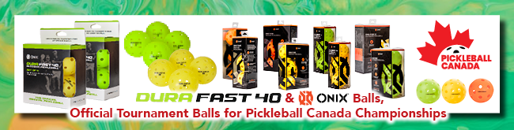
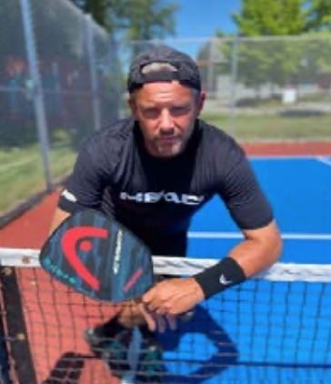 | Steve Deakin and Linda Jefferies  Steve, we understand that you have had an unfortunate injury. What happened? What is your rehab? What are you doing to fill your time?  For the past year, I've had so many people call, text or email to find out where I went and when I'm coming back to the tour. I still can't give a definitive answer, but I will be back. I will compete again. Right now, I'm dealing with details and I'm determined that my health will be nothing less than 100% when I arrive.  Last year I had a nagging problem deep inside my wrist. Just an undetermined pain that I couldn't seem to locate, nor could a Doctor or an MRI for that matter. The pain was inhibiting my ability to play at the sport’s highest level, and it was hard to stomach. I was getting frustrated as were my partners, I'm certain. There is an inordinate amount of stress on an athlete to perform and especially so when your journey includes a partner, i.e., doubles play. By the time I got to the U.S Open in Florida, my wrist was tapped out. I took a hard drive during a fire fight and I heard an audible crack sound. With the medical community's options, I took a joint full of Cortisone and that seemed to do the trick for a while, but as it wore off the pain returned as did my sub-par results in tournaments. I had a decision to make.  I was given so many tidbits of advice that I'm extremely thankful for. Some helpful and some not but I'm overwhelmed at peoples’ kindness and attention to health matters. I finally made the decision to have surgery to clean up what was happening inside the wrist. And as you can imagine, top tier pickleball is a wrist annihilating venture so there was a huge mess inside it. When the surgeon went in doing his thing, he noticed a substantial ligament tear that went unnoticed by every test so far and one that he couldn't tend to at that particular time. So now I had to work on my rehab and hope that the initial tear wasn't an issue. If it proves to be? I'm back to the drawing board with two more surgeries to repair. I'm hopeful and feeling better every day but just not 100% yet.  In the interim, I've partnered with a local sport facility owner and I'm doing a ton of coaching which is well needed here in my hometown. I do intend on moving across Canada eventually but I'm just waiting for the chips to fall where they may in regard to Covid, injury, etc. Life has thrown so many curveballs in the last two years but I'm hoping to now see light at the end of the tunnel. Thanks for tuning in and always for your support!
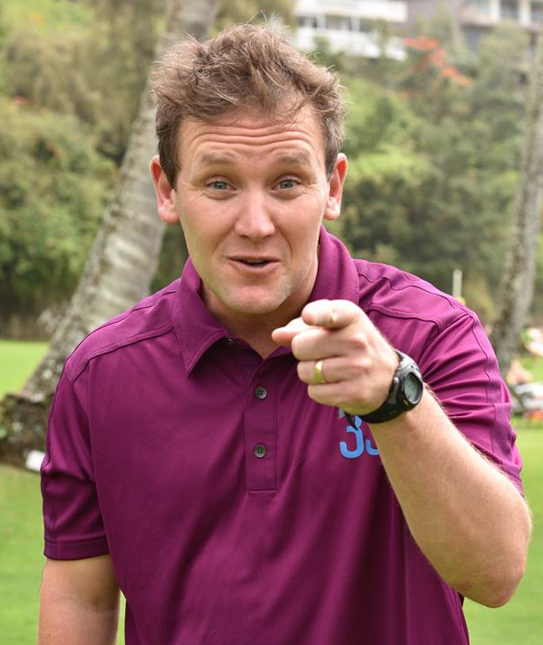 | Knowing Where to Tap  Mark Renneson  I want to tell you a little story. At first it might not be obvious what it has to do with coaching pickleball, but I promise it will become clear.  Once upon a time there was an office, and the manager of this office had a problem. For some reason, all of the computers in her office were no longer working — “a software issue”, she was told by one IT worker who was sent to fix the problem but couldn’t. A half dozen more technicians streamed through the building, each one furiously typing away, rebooting machines, re-writing code, even pulling out and attaching their own devices that were “guaranteed” to set things straight. They all inevitably failed. It was clear that there was a lot of effort being made by these workers, but not much progress.  The manager then received a text. It was a tip from a friend about someone who might be able to help. So she called the number and the man on the other end said he’d be right over. He arrived and sat down in front of one of the machines.  Slowly, methodically, he hit a few keys and then stopped to carefully read what looked like gibberish to the manager. This was in great contrast to the other techs whose fingers had been going a mile a minute and who never really seemed to read what was in front of them.  Whatever this man was doing, it was different. He was bringing up screens of information the manager had not seen any of the other techs access. And with a couple more gentle, deliberate keystrokes, the man stood up, pushed in his chair and said, “Well, that should do it.”  The manager couldn’t believe her ears. This stranger came in, hit the keyboard less than 20 times, and declared the problem solved? A minor miracle!  As he was packing up his bag, the manager asked, “So what do I owe you?”.  The man replied, “Eight thousand dollars.” “Eight thousand dollars?!?!” the manager repeated, as though she misheard him the first time. “Really?”. “Yes.” said the man. “But you were here just a few minutes, you barely touched the keyboard.” “That’s right”, said the man. “Would you prefer I spent several days on this problem, because I can do it that way if you like?”  “No. Of course not” said the manager. “It just surprises me that you could solve the problem so quickly and all the other people who tried couldn’t do it at all.”  “That’s because I know where to tap.” said the man as he handed her an invoice and headed toward the door.  I don’t know whether this story is true — it was told to me by a friend who claims it happened to his brother-in-law. Either way, it is a nice illustration of the value of expertise, and I often think about it in relation to pickleball coaching.  The best teachers I know (both on and off the pickleball court), are just like the expert tech — they are masters at knowing where (and when) to tap. In a pickleball coaching context this means having the skill to understand the players they are working with as well as having a clear picture of what is possible for them, and the steps needed to get there. It means knowing when to switch up a drill and when to allow it to go a little longer. It means being able to manage people effectively, partnering people to bring out the best of them. It means learning to say the right thing, in the right way and at the right time. It also means knowing when to say nothing.  Being an effective instructor or coach is a little about pickleball — but it is a lot about people. With the National Pickleball Coach Education Program, we are working hard to develop a new generation of thoughtful, deliberate, and competent instructors. We are developing pickleball coaches who know where to tap.
Alan Thomson

2022 Rule Changes

USA Pickleball & the IFP have issued a DRAFT copy of the 2022 Rule Book. This year the Significant Rule Changes have been highlighted prior to the table of contents. These changes are subject to change prior to their official release in early January of 2022.

- Spin Serves
In 2022, a player can spin the ball before striking it on the serve, but only one hand at a time can contact the ball before the ball is hit. No foreign substances, material, apparatus, or additional body parts can be applied to the hand or aid the hand that releases the pickleball.
- The Drop Serve
No changes were made to the drop serve other than to remove its Provisional status.
- Wrong Score Called
The rules concerning what happens if the wrong score is called by a player or a referee have changed. If a player thinks a wrong score has been called, a player may stop play to ask for a correction before the ball is served. If it has been served, the rally is to be played out and the score correction (if any) is made before the next serve occurs.
- A Dropped ball
In non-officiated matches, it is not uncommon for a player to carry an extra ball. If an extra ball is carried, it must not be visible to the opponent. If a player accidentally drops an extra ball during a rally, it will result in a fault. This does not apply in an officiated match because the referee is responsible for removing any extra pickleballs from play.
- Medical Time-outs Called by a Referee
If a referee, in the interest of player safety, determines that either medical personnel or the Tournament Director should be consulted for a player health issue, that time-out is not chargeable to the player as a medical time-out. The player retains the right to call their own medical time out later in the match, if needed.
- Verbal Warnings
A referee may now issue verbal warnings for more than just profanity. Any situation that could result in a Technical Warning may instead be addressed by the referee as a verbal warning. Only one verbal warning per match, no matter what the infractions, may be issued to a team, or player in singles.
- Calling the Score after a 15 second warning
Instead of a referee calling the score immediately after the 15 second warning expires, the referee will call the score after the players are ready or should be ready.
- When can a Technical Warning or Foul be called?
Referees are empowered to issue Technical Warnings or Technical Fouls for various reasons, but it has been unclear exactly when a technical should be announced. The 2022 rules now make it clear that a referee will not stop a rally to call a technical warning or foul on an offending team. Any technical warnings or fouls will be assessed after the rally is over.
- Earbuds
While some sports allow coaching during active play, pickleball does not. Since it is possible that a player could receive coaching via earbuds, earbuds will not be permitted on the court during tournaments, with the exception of hearing aids.
- Tournament Score for a Retirement
The score recorded for a player or team that elects to “retire' from a match has been revised to allow the actual scores of the match to be recorded. A team retiring may play additional matches in their bracket if any are warranted.

Pickleball BC and Tennis BC Joint Task Force
Tennis BC and Pickleball BC formed a Task Force earlier this year to promote adequate public facilities for both sports, reduce the conflict that sometimes arises at shared courts, and share best practices.

Pickleball Canada and Tennis Canada plan to use this document as the foundation for a ‘National’ recommendation with the goal of increasing cooperation between tennis and pickleball associations in addressing the problem of inadequate pickleball facilities. The development of the National Recommendation is underway.

This is an excellent document that should be shared with cities and municipalities across Canada to support the establishment of more pickleball facilities.

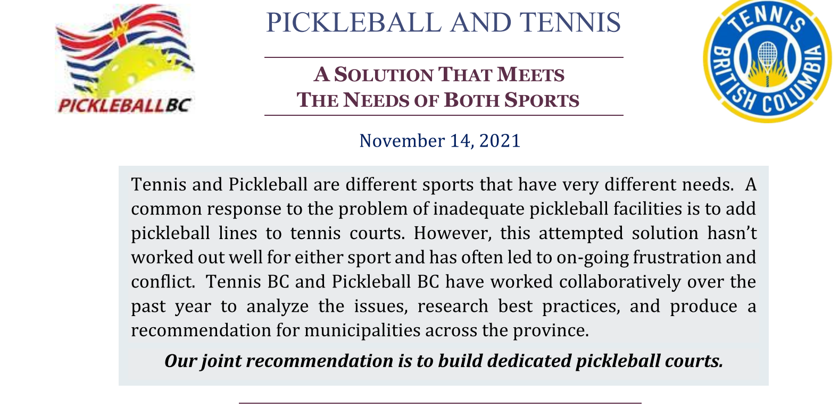

Read Full Joint Recommendation.
Joint-Recommendation-v8.1.pdf (tennisbc.org)

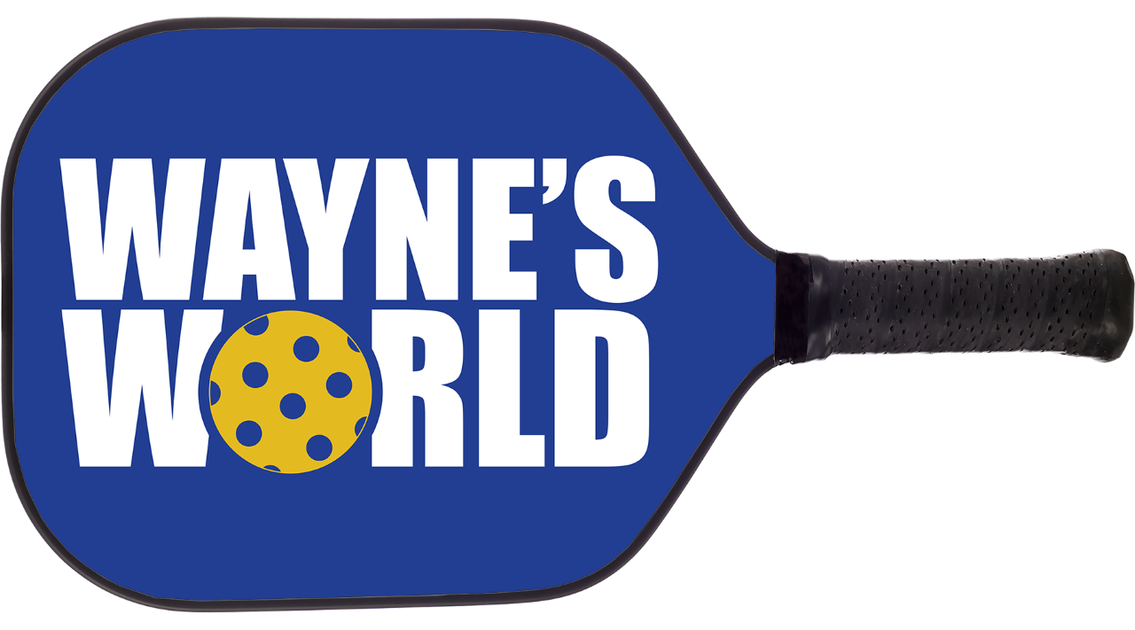  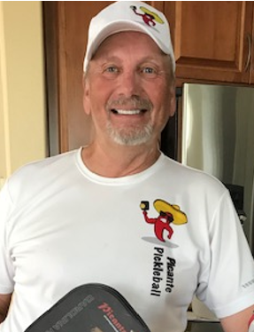 | The Third Shot Drive, who needs it?  Opinion by Wayne Kerr  Everyone does! This is an important part of the game and should be a part of your arsenal.  While it’s true that the drive is often one of the first shots learned by a player, many people don’t execute it very well. Too often players, especially at the lower levels, make a lot of errors trying to win the point outright with their drive, often over-hitting it. Unless there is an obvious opening, better players use the third shot drive to set up their next shot.  There are many reasons to hit a third shot drive. Here are just some of them:  - A weak return of serve has created an offensive opportunity by either landing short, sitting up high or both. Go for it, this may be your best offensive chance all point.  - Your serve was deep and you can keep the returner back with a third shot drive. This can allow you and your partner to gain the net and keep your opponents back.  - Use the drive to set up an easier fifth shot drop.  - Cause a pop up for your partner to put away (often referred to as: ‘The Shake and Bake’).  - Perhaps your third shot drop isn’t as good as it should be (if this is the case keep practicing).  - For variety. If you hit a lot of third shot drops, throw in the occasional drive to keep your opponents from getting too comfortable or to shake things up.  - Driving the ball can neutralize a return that has a lot of spin.  Keep in mind, the third shot drive can be a risky shot. When you hit the ball hard there is more risk of it going beyond the baseline, therefore you must keep it low which brings the net into play. Depending upon how hard the ball has been hit it may only have a window of 10 to 12 inches (25 to 30 cm) above the net. Hitting below the window puts the drive into the net, above sends the ball long. The net is two inches lower at the center than the sides, so driving it there allows a better chance of clearing the net, thus lowering your risk slightly. Driving the ball cross-court allows a longer flight path before the ball travels beyond the baseline rather than one hit down the line or straight ahead.  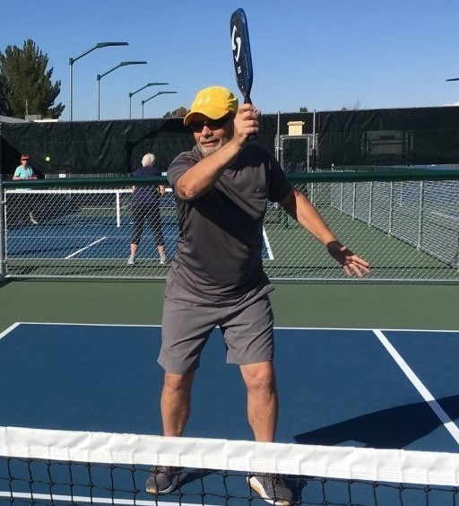  Driving the ball at less than full blast also increases the chances of it landing inbounds. A controlled three-quarter pace shot will often attain the same result as a riskier, harder hit shot. Adding topspin to the ball will also increase the margin of error. Hitting a ball with topspin at less than full blast can produce a ball dipping at your opponent’s feet which can be difficult to handle. Another way to reduce risk is to keep the target zone as large as possible. Driving the ball toward center allows you to hit the ball several feet wide of your target and still keep it in play. If you aim toward a sideline this may not be the case.  “The middle solves the riddle.” Almost all of us have heard these words or something similar. Driving the ball up the middle will occasionally cause confusion over which of your opponents is taking that ball. Even a slight hesitation can cause an error or mishit.  Am I suggesting that all third shot drives should be directed down the middle? Of course not, there are many reasons to aim toward one of the players or the sidelines: attacking a weaker player or backhand for example, or to open up the center of the court, or because a player is out of position, or to pull a strong player away from the middle area, etc. Just don’t forget that the net is higher on the sides and hitting down the line requires the shortest ball flight path.  Possessing a reliable Third Shot Drive is an important asset to add to your repertoire. Remember to think of it as a setup shot and you won’t be surprised when the ball comes back over the net. As a friend of mine says: If pickleball were war, think of the drive as the air assault before the ground invasion. When the rare opportunity arises to go for an outright winner, be ready to go for it. If, heaven forbid, you should happen to miss (everyone does, even the best players in the world) shake off your disappointment quickly and get ready for the next point. Pickleball is fun and getting more balls in play makes it even more enjoyable.  Party on, my pickleball friends!
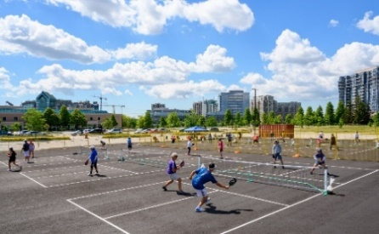 | The BEST Parking Lot Pickleball in Canada  Chuck Mitchell  That is what the members of Markham Pickleball Club (MPC) affectionately called the 6 temporary courts that were set up on the Markham City Hall parking lot this past summer.  As many of us are aware, Pickleball is the fastest growing sport in North America, and some will say the world. The result of this growth is a reality that almost everywhere there is a shortage of courts to play on. In Canada during the winter, while there are some dedicated pickleball facilities, the majority of play happens on badminton courts (exact same dimensions as a PB court) in community centres, Churches, etc. When spring comes and the birds are singing most picklers move outside, and while there are some lucky ones that get to play on dedicated pickleball courts, a significant number of players share space on public tennis courts. While this option is better than no PB courts, there is often friction between tennis & pickleball players and the result isn’t ideal for either sport.  Pickleball is a very social sport and unlike Tennis, where often 2-4 players show up and play for an hour or less, as described by Chuck Mitchell, Pickleball Ontario’s Ambassador for Markham, Pickleballers are like locusts… they show up in swarms and play for hours and hours seven days a week. The city of Markham Recreation Department, after trialing shared public tennis/pickleball courts for 2 years, came to the conclusion that each sport needed its own dedicated courts. In the spring of 2022, 8 beautiful dedicated Pickleball courts will open in a new park which will be the first of many Pickleball court complexes built in the coming years.  Now back to Parking Lot Pickleball. In early 2021, the challenge facing the newly formed Markham Pickleball Club and the City of Markham was where people could play in the summer of ‘21. After considering several options, a decision was made to use space available in the city hall parking lot (because of work from home during covid-19). While the surface was not ideal and the grade of the parking lot made for some interesting shots, on Wednesday May 26th MPC opened for play. MPC quickly developed an identity as a great, fun place to play and a truly inclusive club. To say the experiment was a success is an understatement. By the end of October, we had 260 paid members, we provided free “Learn to Play” clinics to over 80 people, and 7 days a week we had 30-50 people playing during hosted hours during the day and evenings.  The Best Parking Lot Pickleball in Canada wasn’t perfect, but it was home and it was an amazing way to start the Markham Pickleball Club Legacy.  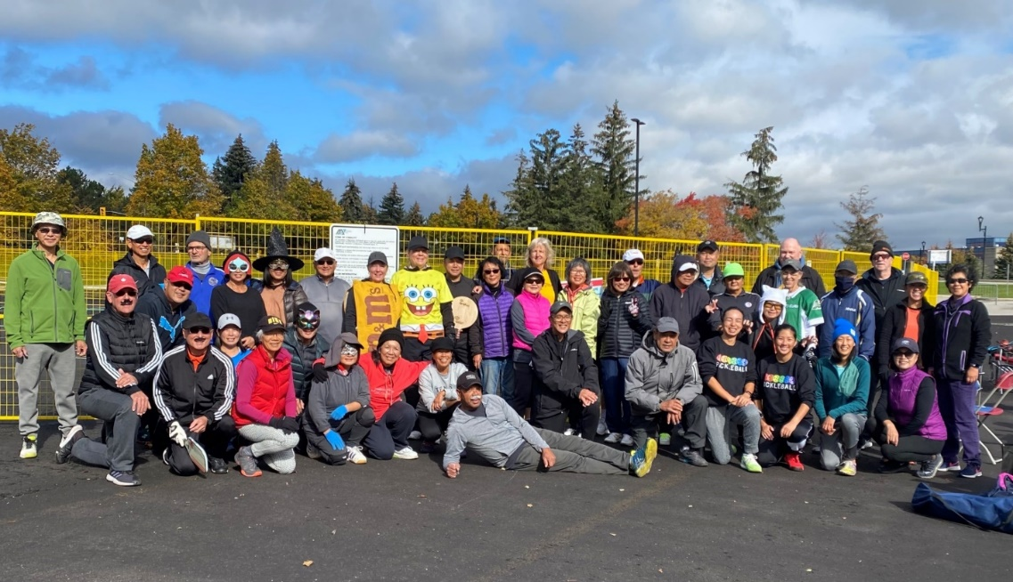  Final Day of the Season
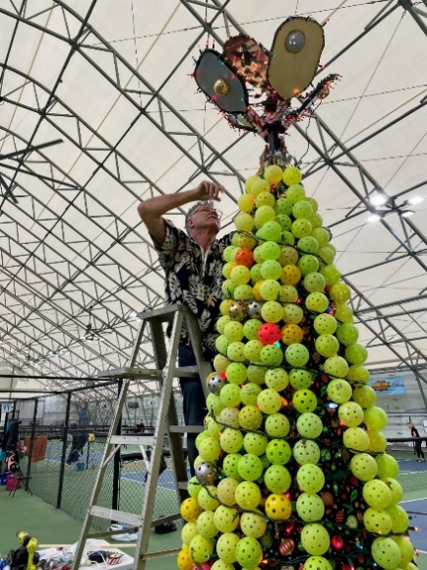 | Big Tree…Bigger Hearts  Anne Longley  What's more than 12 feet tall, has 350 pickleballs, craves large amounts of canned food and is a one-of-a-kind creation? The Okanagan Wealth Advisors (OWA) Pickleball Complex in Vernon is now home to what is perhaps the tallest pickleball Christmas tree in the world.  The Vernon Pickleball Association (VPA) likes to do things in a big way. The OWA Pickleball Complex is the largest dedicated (all season) covered Pickleball complex in Canada. The VPA has nearly 700 members, which is double what they had in 2018, and the VPA members have big hearts…having raised more than $1.2 million in 2020 to ‘raise the roof’ on the courts.  VPA President, Myron Hocevar, says, "I'm very thankful for having so many dedicated club members who volunteer their time and energy to make the VPA a success, and this includes Marco Longley who designed and built the tree". Marco collected broken pickleballs for months before building the tree in his garage and is now challenging other clubs to create their own pickleball inspired Christmas trees and to collect donations for their local food bank.  The tree is standing tall and brightly lit inside the OWA Pickleball Complex and members are encouraged to hang a tree decoration from home and to bring non-perishable food items to donate to the Vernon Food bank.(www.vernonhouseofhope.com/foodbank) The VPA has set a lofty goal of 1,000 pounds of food and hygiene products donated before Christmas.  For more information about the Vernon Pickleball Association, please visit their website at www.vernonpickleball.com  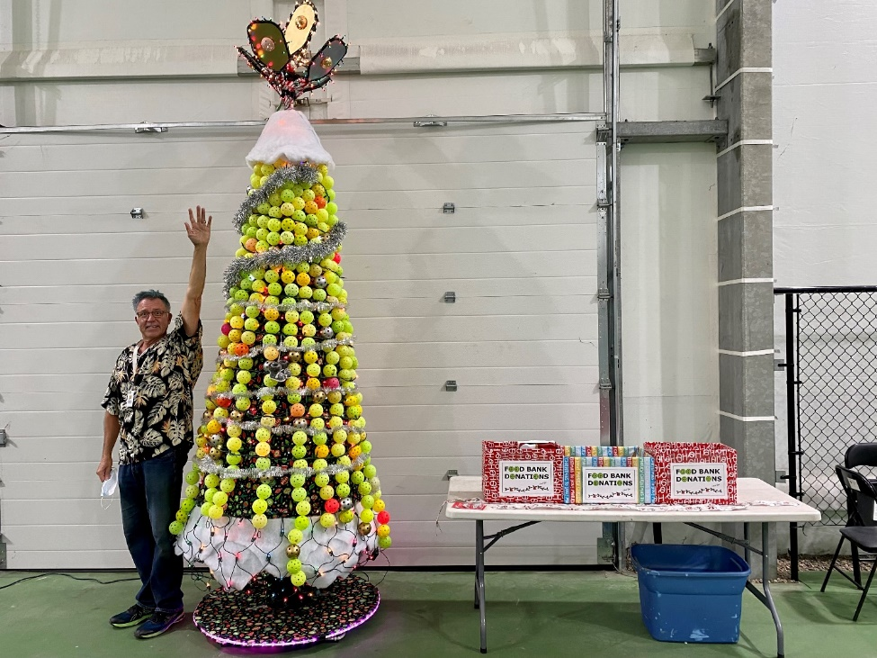
 | Contributors:  Karen Rust  Steve Deakin  Mark Renneson  Alan Thompson  Wayne Kerr  Chuck Mitchell  Anne Longley |  | Debbie Mackay  Linda Jefferies  Carla Anderson  Manon Lussier  Robert Hogue  Isabelle Gauthier  Bill McGregor  Adam Stacey
On the lookout for Contributors

We would love to share your stories, club events, photos, news, etc. Let us know if you have any ideas for content that would serve our membership.
We invite you to contact Debbie Mackay at scoop@pickleballcanada.org
We know you are out there, and we are looking forward to hearing from you!

