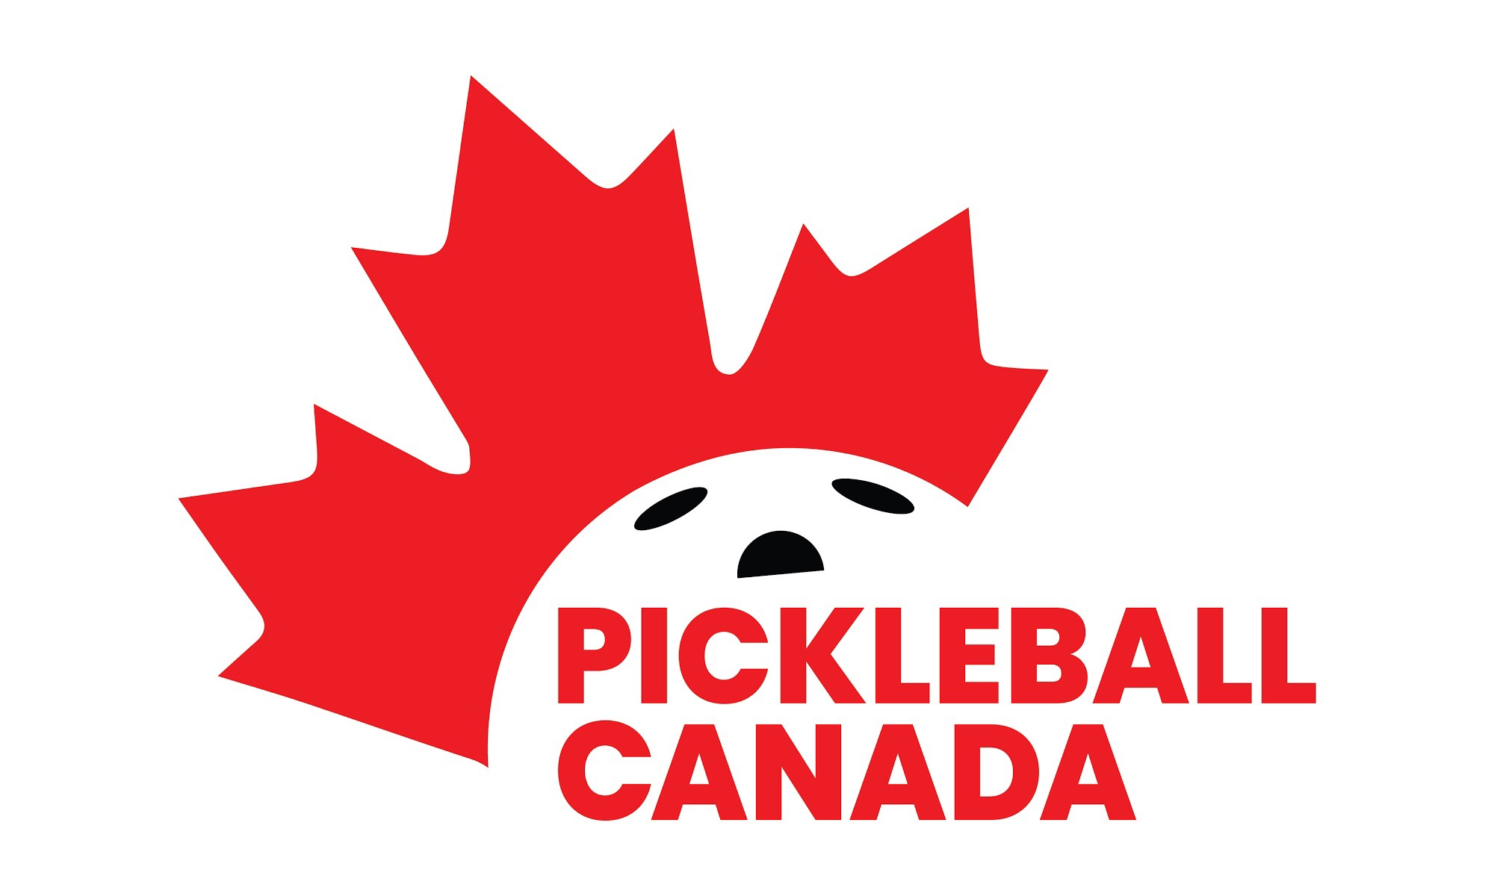

2022 RULE CHANGE HIGHLIGHTS

The complete, updated International Federation of Pickleball Rulebook is expected to be available at the beginning of January. Rule changes are effective January 1, 2022.

Following are the major rule changes that recreational and tournament players need to be aware of:

Spin Serves
In 2022, a player can spin the ball before striking it on the serve, but only one hand can contact the ball before the ball is hit. No foreign substances, material, apparatus, or additional body parts can be applied to the hand or aid the hand that releases the pickleball. This eliminates what has been called the ‘chainsaw’ serve.
The Drop Serve
No changes were made to the drop serve other than to remove its Provisional status.
Wrong Score Called The rules concerning what happens if the wrong score is called by a player or a referee have changed. If a player thinks a wrong score has been called, a player may stop play to ask for a correction before the ball is served. If it has been served, the rally is to be played out and the score correction (if any) is made before the next serve occurs.
A Dropped Ball In non-officiated matches, it is not uncommon for a player to carry an extra ball. If an extra ball is carried, it must not be visible to the opponent. If a player accidentally drops an extra ball during a rally, it will result in a fault. This does not apply in an officiated match because the referee is responsible for removing any extra pickleballs from play.
Calling the Score after a 15 second warning Instead of a referee calling the score immediately after the 15 second warning expires, the referee will call the score after the players
are ready or should be ready.
Medical Time-outs Called by a Referee If a referee, in the interest of player safety, determines that either medical personnel or the Tournament Director should be consulted for a player health issue, that time-out is not chargeable to the player as a medical time-out. The player retains the right to call their own medical time out later in the match, if needed.
Verbal Warnings A referee may now issue verbal warnings for more than just profanity. Any situation that could result in a Technical Warning may instead be addressed by the referee as a
verbal warning. Only one verbal warning per match, no matter what the infraction is, may be issued to a team, or player in singles.
When can a Technical Warning or Foul be called? Referees are empowered to issue Technical Warnings or Technical Fouls for various reasons, but it has been unclear exactly when a technical should be announced. The 2022 rules now make it clear that a referee will not stop a rally to call a technical warning or foul on an offending team. Any technical warnings or fouls will be assessed after the rally is over.
Earbuds While some sports allow coaching during active play, pickleball does not. Since it is possible that a player could receive coaching via earbuds, earbuds will not be permitted on the court during tournaments with the exception of hearing aids.
Tournament Score for a Retirement The score recorded for a player or team that elects to “retire' from a match has been revised to allow the actual scores of the match to be recorded. A team retiring may play additional matches in their bracket if any are warranted.

